Exciting news!
There is a new way to pay for parking with our ParkMobile software. ParkMobile is replacing the Flowbird app and Flowbird Pay by Text, starting March 16th, 2026.
A link to the “how to” is available here: ParkMobile How-To
Here are all the payment options available for Pay Station parking.
Payment Options
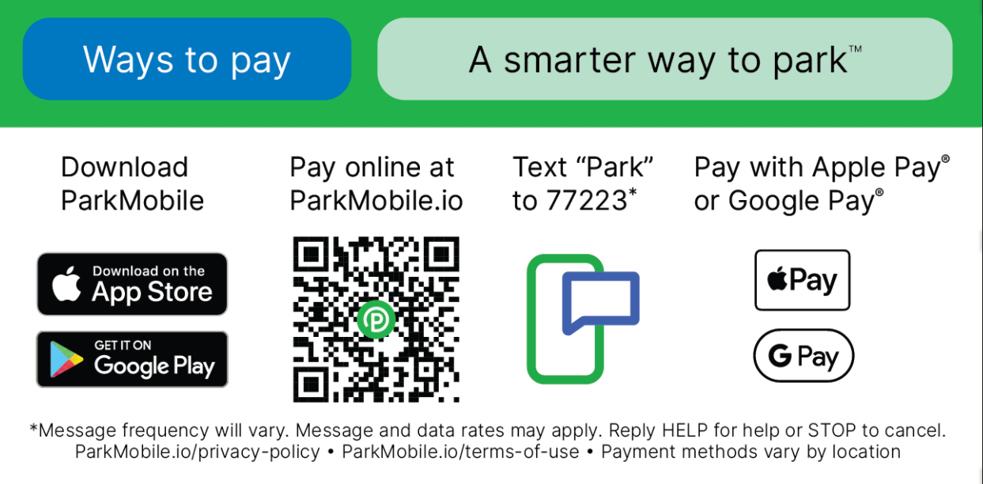
ParkMobile FAQ - ParkMobile Digital Payments FAQ 2025

When parking at a Pay Station, faculty, staff and students must have a current decal and pay the pay station.

